**DS 510 – Week 3**

**Assignment**

1. A sample of **160** workers in the downtown area classified each worker by race. A bar graph of the results is given below, but the bar for blacks in the graph below has been omitted.

Using the information provided, the *proportion* of black workers in the sample must be:

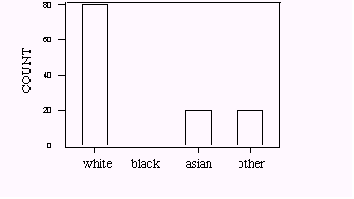

1. The following is a sample of the weights of 12 boxers from various weight classes:

121 173 157 165 170 161 142 171 184 100 145 196

What is the median value of this data set?

1. The following is a sample of the weights of 12 boxers from various weight classes:

121 173 157 165 170 161 142 171 184 100 145 196

How many values are going to be considered outliers?

1. Too much cholesterol in the blood increases the risk of heart disease. The cholesterol levels of young women aged 20 to 34 vary approximately Normally with mean 185 milligrams per deciliter (mg/dl) and standard deviation 39 mg/dl. About what percent of young women in this age group will have cholesterol levels less than 150 mg/dl?